ARCHITECTURE OF FLIGHT BOOKING SYSTEM

PHYSICAL TIERS LOGICAL TIERS AND LAYERS

Client Tier


Middle Tier


Data Tier

Presentation layer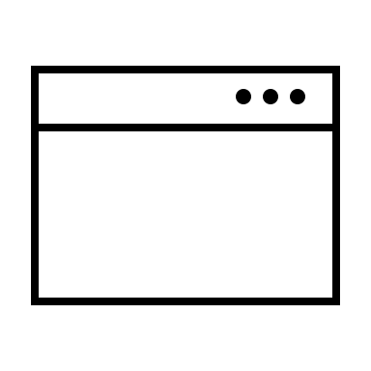
URL Single page App

UI Web Service
Next.js client .NET (C#)

APPLICATION SERVER

MongoDB

React.js
DAO (Persistence) layer
Business layer
Service layer

